An Activity-based Curriculum for Large Introductory Physics Classes:
The SCALE-UP Project

Jeffery M. Saul
Department of Physics, University of Central Florida, Orlando, FL 32816-2385

Robert J. Beichner
Department of Physics, North Carolina State University, Raleigh, NC 27695-8202

Abstract
The Student-Centered Activities for Large Enrollment Undergraduate Programs (SCALE-UP) Project offers instructors of large introductory science classes an economical and effective alternative to the lecture/laboratory format. Basically, North Carolina State University, the University of Central Florida, and a group of collaborating schools are utilizing the collaborative, interactive, research-based instruction that works so well in smaller class settings and finding ways to economically accommodate studio-style classes of up to 100 students. Lecture and laboratory are blended together in an approach that uses technology and minimal lecturing to create a highly collaborative, technology-rich, hands-on, interactive learning environment. In addition to developing classroom designs and management techniques, the project involves the development, evaluation, and dissemination of curricular materials for introductory physics that support this type of learning.
In comparisons to traditional instruction we have seen significantly improved performance in problem solving, increased conceptual understanding, improved attitudes, and much higher student success rates, especially for females and minorities.

It is known that students can learn more physics in classes where they interact with faculty, collaborate with their peers on interesting tasks, and are actively involved with the material they are learning.¹ Research on learning and curriculum development has resulted in sets of instructional materials that correct many of the shortcomings of traditional physics instruction. Careful studies of these research-based introductory curricula in small classes indicate that they can significantly improve students’ conceptual understanding and problem solving skills. However, introductory physics instructors with large classes who want to incorporate active learning into their classrooms must currently choose between hands-on activities in small class sections² that supplement the lecture (recitation or laboratory sections) and interactive lecture activities³ for larger classes that do not permit hands-on experiments and limit faculty interactions with individual groups. Studio classes like SCALE-UP offer instructors another choice by replacing the lecture/laboratory format with 4-6 hours of activity-based instruction per week, typically in 2-hour blocks. Since the entire class is taught in the same room with the same students and instructors in each class, the laboratory and other activities can be arranged to build on one another in sequence for greater learning impact than when taught in a small section running parallel to the lecture course. As with the research-based curricula described above, the students work through the activities in groups of 3-4 students each. However, both the activities and the classroom have been modified for larger student/faculty ratios of 25-33 to 1, which permits class sizes of 50-100 students. Thus SCALE-UP makes it practical to offer activity-based classes with integrated hands-on labs even at large universities, like NC State and UCF where thousands of students are enrolled in the university physics classes each year. This type of class takes advantage of cooperative learning techniques and helps students form learning communities which can make education at large universities seem much less impersonal, particularly for students taking mainly large introductory classes in their freshman and sophomore years.
The main learning objective of the SCALE-UP courses is to help students build a good functional understanding of physics and develop problem-solving skills so that they can use what they learn to solve problems in new contexts. This objective can be broken into the following 6 measurable outcomes.
Students should:
- understand and be able to apply fundamental physics concepts.
- begin to develop expert-like problem solving skills.
- be able to address and solve complex problems.
- improve communication, interpersonal, questioning, & teamwork skills.
- develop good laboratory skills including being able to design, carry out, and analyze an experiment.
- use computers to look up information, take and analyze data, run simulations, and to develop mathematical models of physical situations.
In addition, we also wanted to reduce the high failure rate (>25%) of introductory physics students and have students perceive the SCALE-UP classes as a positive physics learning experience.
For 2.5 years, the SCALE-UP team at NC State worked with both semesters of the calculus-based physics sequence using a specially designed multimedia classroom for 54 students to teach the introductory physics course for engineering majors (see Figures 1 & 2). This was an intermediate step to the full-sized SCALE-UP classes (80-100 students) of which the NC State classroom in figure 3 is the first. Both the laptops and the round tables are key elements for working with large student to faculty ratios. They both encourage student groups to exchange information with one another letting the students help each other when instructors are working with other tables. In addition, the table arrangement aids in the distribution and collection of class materials while closing the laptops removes them as a distraction during class discussions.
The curriculum materials include adaptations of research-based/informed activities from the literature to the SCALE-UP classroom as well as activities developed specifically for SCALE-UP. The curriculum consists of short lab activities and problems, real-world group problems, and longer lab activities. Technology is used only when it improves student learning or classroom management. A SCALE-UP instructor’s manual with step-by-step guide to activities and student materials is available online.⁴
In the 3 years we have been working with SCALE-UP classes, we have seen the following improvements compared with students in the regular lecture classes: ⁵
- Improved performance (2-4x the gain) on nationally-normed concept tests (see Table 2) and conceptual exam problems,
- Better scores on common exam problems (SCALE-UP students outperform their peers on at least 70% of common exam problems),
- Significant gains on conceptual exam questions that target particularly robust student difficulties,
- Student responses to exam problems and think-aloud interviews show that SCALE-UP students demonstrate increased ability to address complex problems in new contexts by using an expert-like problem solving strategy,
- Observations of students working “on task” practicing good teamwork and communication skills,
- Observations of students making coherent class presentations of their solutions to complex problems,
- Students asking more and deeper questions on the course material during class,⁶
- Most SCALE-UP classes performed at least one laboratory activity where they designed and carried out an experiment to answer an open-ended question,
- The SCALE-UP students demonstrated better attendance (> 85%) and
- The overall course failure rate⁷ was cut in half–even as we demanded higher performance and more work from the students.
Females and minorities seem to especially benefit from the new learning environment. Their respective failure rates dropped to ¹/₃ and ¹/₄ of the rates in our traditional sections of these courses. In focus groups, in interviews with visiting faculty, and in department evaluations, SCALE-UP students indicate they recognize they are doing more work than the regular classes, but they feel it is worth it because they are developing a deeper understanding of the course material.⁸ Over 70% of the students prefer SCALE-UP to traditional lectures.
Word of our success is spreading. Other departments at NC State are beginning to utilize SCALE-UP pedagogical techniques and classroom designs. In addition, over 40 faculty and administrators from other institutions have come to visit the SCALE-UP classroom. In addition, ten colleges and universities have committed to adopting this.⁹ Even though most of the interest expressed so far has been in physics, it is important to realize that the SCALE-UP approach to large introductory courses has the potential to radically change the way other science, engineering, and mathematics classes are taught at large colleges and universities.¹⁰
We would like to thank the U.S. Department of Education FIPSE program (PB116B71905 & P116B000659), the National Science Foundation (DUE-9752313 & DUE-9981107), Hewlett Packard, Apple Computer, and Pasco Scientific for their generous support.

References:
There are many references in the literature including: K. Cummings, J. Marx, R. Thornton, and D. Kuhl, “Promoting innovation in studio physics,” PER Supplement to Am. J. Phys. 67 (7), S38-S44 (1999); R.R. Hake, “Active engagement vs. traditional methods: A six thousand student study of mechanics test data for introductory physics courses,” Am. J. Phys. 66 (1), 64-74 (1998); E.F. Redish, J.M. Saul, and R.N. Steinberg, “On the effectiveness of active-engagement microcomputer-based laboratories,” Am. J. Phys. 65 (1), 45-54 (1997); P. Laws, “Millikan Lecture 1996: Promoting active learning based on physics education research in introductory physics classes,” Am. J. Phys. 65 (1), 13-21 (1997); P. Heller, R. Keith, and S. Anderson, “Teaching problem solving through cooperative grouping. Part 1: Group versus individual problem solving,” Am. J. Phys. 60 (7), 627-636 (1992); A. Van Heuvelen, “Learning to think like a physicist: A review of research based instructional strategies,” Am. J. Phys. 59, 898-907 (1991).
2 L.C. McDermott and P.S. Shaffer, Tutorials in Introductory Physics (Preliminary edition) (Prentice Hall, Upper Saddle River NY, 1997); P.W. Laws, Workshop Physics Activity Guide (Wiley, New York NY, 1997); and University of Minnesota’s Cooperative Group Problem Solving curriculum (see http://www.physics.umn.edu/physed/)
3 E. Mazur, Peer Instruction: A Users Manual (Prentice Hall, New Jersey, 1997); D.E. Meltzer and K. Manivannan, “Promoting interactivity in physics lecture classes,” The Physics Teacher 34, 72-76 (1996); and D.R. Sokoloff and R.K. Thornton, “Using interactive lecture demonstrations to create an active learning environment,” The Physics Teacher 35 (6), 340-347 (1997).
4 The materials will be available at a password protected website. Look under SCALE-UP at www.ncsu.edu/PER for more information.

5 More details on the evaluation can be found in the online version of this article at the URL in Ref. 4.
6 Based on comments made by classroom visitors and our outside evaluator, Karen Johnston, who taught introductory physics for many years at NC State.
7 Failure rate refers to the percentage of students in a class who do not achieve at least a C- letter grade.
8 For example, 12 students in a 2nd semester SCALE-UP class talked to evaluators from M.I.T. All had been in regular lecture for the 1st semester course. The students indicated that while they were doing more work than students in the regular classes, they felt they were learning more. 10 students preferred the SCALE-UP format, 1 indicated no preference, and 1 preferred lecture because he could get the same grade with less work.
9 The 10 schools are UCF, MIT, Rochester Institute of Technology, University of New Hampshire, Coastal Carolina, University of Alabama, University of Western Kentucky, American University, Wake Tech Community College, and NC State.
10 NC State and UCF began to teach introductory SCALE-UP chemistry classes this past year.

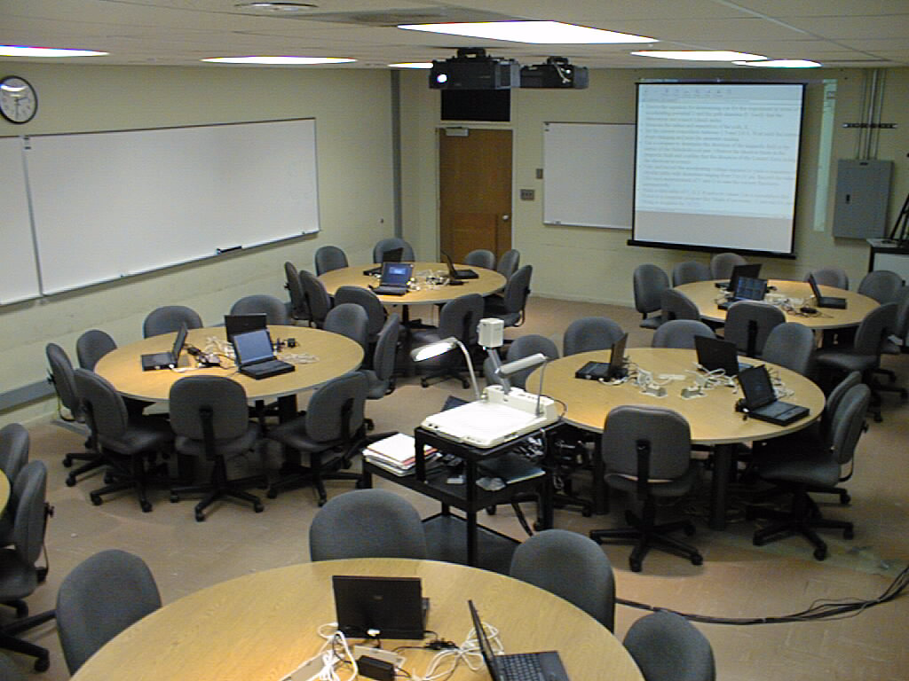
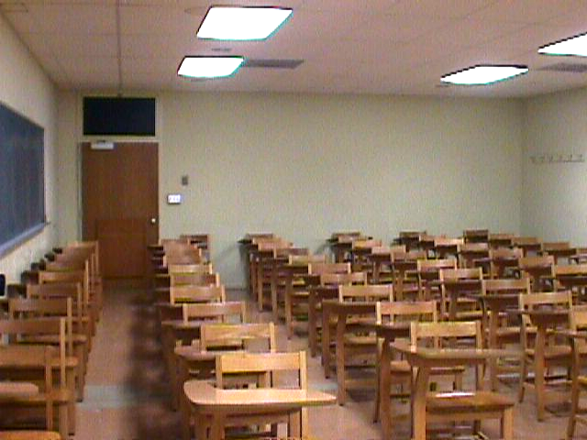

Figure 1. (Above) The medium-size
SCALE-UP classroom before renovation,
seating 55 students.
Figure 2. (Top right) The same classroom
after renovation now seats 54. Displays from the instructor station (center of room) are projected on opposite sides of the room. Each table has 3 groups of 3 students each. Each group has access to a networked laptop. Laptops save space and promote interactions between groups at the same table. These interactions allow groups to assist one another when instructors are working with other tables.
Figure 3. (Right) The NC State full-size classroom seats 99 students at 11 tables. This room was first used in Spring 2001.
Table 2: Diagnostic tests results from SCALE-UP project classes at NCSU and UCF using the normalized gain h, where h = (avg. post score – avg. pre score)/ (maximum score – avg. pre score) and Avg. means the class average. Note that for each of the four concept tests, the SCALE-UP classes are achieving 2-4 x the normalized gains of the traditional lecture classes.
 | h from 1st Semester classes: Mechanics
 |  | FCI |  | FMCE
Traditional Lecture classes Avg. NCSU / UCF |  | 0.21 / 0.20 |  | 0.10
Medium SCALE-UP classes NCSU / UCF |  | 0,38, 0.42, 0.52*/ 0.43 |  | 0.38
Large SCALE-UP class NCSU (99 students) |  | 0.40 |  | 0.38
 | h from 2nd Semester classes: E&M + Optics
 |  | CSEM |  | Direct
Traditional Lecture classes Avg. NCSU |  | 0.14 |  | 0.10
F98 SCALE-UP class NCSU |  | 0.21 |  | 0.17
F99-S00 SCALE-UP classes NCSU |  | 0.28, 0.36 |  | 0.21*, 0.38
* Precourse data was not collected for this class. Precourse avg. was conservatively determined from other diagnostic tests & pretest values from previous semester avg. score.

